



Fiji-MARKETS FOR CHANGE ELEVEN monthS PROGRESS report – JANUARY- NOVEMBER 2016
- Name of the program, duration and funding:
The Markets for Change (M4C) UNDP project is a six-year project covering the period of 2014-2019. The project is principally funded by Australia’s Department of Foreign Affairs and Trade (DFAT) as part of the Pacific Women Shaping Pacific Development initiative.
The M4C UNDP project is Outcome 2 of the overall UNW M4C Project and funding via UNW for the UNDP component is US$1,059,722 with US$586,520 for Fiji, US$206,361 for Solomon Islands, and US$266,841 for Vanuatu.

- Description of the overall program rationale:
The M4C UNDP project, is aimed at improving the socio-economic security of women market vendors through 2 main interventions:
- Financial literacy and business training through the Continuing Market Business Education (CMBE) program which addresses the following 2 outputs of the overall UNW M4C Project- Output 2.1 - Market vendors’ lives are improved due to strengthened financial competencies and record keeping so that they can better leverage business and financial access opportunities, and Output 2.2 Increased access to financial and social services, including access to savings, credit, payment, micro-insurance and livelihood protection of market vendors.
- Agricultural productivity training through the Improving Productivity and Income for Vendor Farmers (IPI-VF) program which addresses the following Output 2.4 of the overall UNW M4C Project. - Interventions to increase productivity and incomes for farmers and market vendors

- Brief information about project activities implemented over the last eleven months:
Training Intervention Topics
The CMBE program has the following rounds of training in 2016:
- Round 1: Basic Financial Literacy – includes 1.1. Financials First Steps
- Round 2: Improve Your Market Business - 2.1. Produce presentation and customer relations, 2.2. Keeping your records, 2.3. Savings and loans, and 2.4. Business Basics

The IPI-VF program has the following topics of training in 2016:
- Topic 1: Agribusiness and Farm Management
- Topic 2: Soil Care and Nutrients
- Topic 3: Pest Disease and Weed Management
- Topic 4: Harvest/Post-Harvest Handling and Marketing

Activities January to November 2016
CMBE Training Implemented and Numbers Achieved with a particular focus on Reducing Exclusion of Rural Market Vendors (RERMV)

Date | Market (District/Province) | Training Topics | Total trained | No. of Males | No. of Females
23-May | Suva/Nausori (Rewa district, Rewa) | Round 1.1- 2.4 | 27 | 10 | 17
25-May | Suva /Nausori (Verata district, Tailevu) | Round 1.1- 2.4 | 50 | 11 | 39
24-May | Sigatoka (Nasikawa/ Nadroga-Navosa) | Round 1.1- 2.4 | 29 | 1 | 28
24-May | Labasa (Namuka District, Macuata) | Round 1.1- 2.4 | 23 | 0 | 23
25-May | Labasa (Wailevu District/ Macuata) | Round 1.1- 2.4 | 24 | 14 | 10
20-Jun | Nausori (Bau tikina, Tailevu) | Round 1.1- 2.4 | 29 | 6 | 23
20-Jun | Suva (Viria district, Naitasiri) | Round 1.1- 2.4 | 20 | 6 | 14
22-Jun | Suva (Suva District, Rewa) | Round 1.1- 2.4 | 42 | 7 | 35
22-Jun | Suva/Nausori (Navuakece district, Naitasiri) | Round 1.1- 2.4 | 47 | 10 | 37
22-Jun | Nausori/Suva (Nawaidina district,Naitasiri) | Round 1.1- 2.4 | 47 | 8 | 39
28-Jun | Suva/Nausori (Sawakasa & Dawasamu district/Tailevu) | Round 1.1- 2.4 | 39 | 2 | 37
12-Jul | Suva/Nausori (Wainibuka district) | Round 1.1- 2.4 | 45 | 2 | 43
12-Jul | Suva/Nausori (Nagonenicolo/Matillobau district, Naitasiri) | Round 1.1- 2.4 | 50 | 26 | 24
13-Jul | Suva/Nausori (Baulevu Farmer Vendors, Naitasiri) | Round 1.1- 2.4 | 34 | 30 | 4
19-Jul | Suva/Nausori (Wainikoroiluva/ Namosi district, Namosi) | Round 1.1- 2.4 | 50 | 27 | 23
19-Jul | Suva/Nausori (Veinuqa/ Qarawai district, Namosi) | Round 1.1- 2.4 | 40 | 19 | 21
20-Jul | Suva/Nausori (Lakena/Kuku/Vuci) | Round 1.1- 2.4 | 26 | 22 | 4
26-Jul | Sigatoka (Noikoro district) | Round 1.1- 2.4 | 27 | 15 | 12
12-Jul | Suva/Nausori (Wainibuka district) | Round 1.1- 2.4 | 45 | 2 | 43
16-Aug | Nadi (Dratabu village) | Round 1.1- 2.4 | 52 | 43 | 9
17-Aug | Nadi (Nadi Hindi sesh) | Round 1.1- 2.4 | 29 | 24 | 5
16-Aug | Lautoka (Sabeto, Vuda,Vitogo district) | Round 1.1- 2.4 | 37 | 12 | 25
17-Aug | Lautoka (Vuda & Vitogo) | Round 1.1- 2.4 | 15 | 10 | 5
16-Aug | Ba (Toge village) | Round 1.1- 2.4 | 48 | 31 | 17
17-Aug | Ba (Ba Market Bure) | Round 1.1- 2.4 | 34 | 16 | 18
13-Sep | Tavua (Korovou Village) - iTaukei session | Round 1.1- 2.4 | 62 | 26 | 36
14-Sep | Tavua (DO's Conference Room) - Hindi session | Round 1.1- 2.4 | 31 | 19 | 12
13-Sep | Rakiraki (George Shiu Raj conference room) - Hindi session | Round 1.1- 2.4 | 30 | 19 | 11
14-Sep | Rakiraki (Nasukamai Village Hall) - iTaukei session | Round 1.1- 2.4 | 54 | 2 | 52
19-Sep | Tavua (Naila Village) - iTaukei session | Round 1.1- 2.4 | 92 | 11 | 81
20-Sep | Labasa (Wailevu Village Hall) - iTaukei session | Round 1.1- 2.4 | 42 | 0 | 42
11-Oct | Ba (Nasolo Community Hall) - iTaukei session | Round 1.1- 2.4 | 31 | 9 | 22
11-Oct | Sigatoka (Nawamagi Sch Hall) - iTaukei session | Round 1.1- 2.4 | 20 | 6 | 14
11-Oct | Labasa (Batiri Cakaudrove Village) - iTaukei session | Round 1.1- 2.4 | 35 | 0 | 35
18-Oct | Suva & Nausori (Kasavu Village) - iTaukei session | Round 1.1- 2.4 | 44 | 0 | 44
Total |  |  | 1335 | 450 | 885
Total Unique Participants |  |  | 1335
Percentage of Annual Target Achieved |  |  | 111%

IPI-VF Training and Numbers Achieved (no Topic 3 training sessions were due to change in format of T3 training, and Topic 4 was rolled out ahead of T3)

Date | Market (Cluster) | Training Topics | Total trained | No. of Males | No. of Females
April 13-15th | Labasa | Topic 1 | 33 | 15 | 18
April 13-15th | Labasa | Topic 2 | 19 | 12 | 7
April 19- 20th | Nadi | Topic 1 | 22 | 10 | 12
April 21st-23rd | Nadi | Topic 2 | 20 | 5 | 15
May 4th | Nausori (Nasau) | Topic 1 | 29 | 10 | 18
May 10th-11th | Rakiraki | Topic 1 | 37 | 20 | 17
May 16th-17th | Tavua | Topic 1 | 33 | 7 | 26
May 18th-19th | Ba | Topic 1 | 36 | 13 | 23
June 1st | Nausori (Muaniweni) | Topic 2 | 16 | 9 | 6
June 8th | Nausori | Topic 2 | 56 | 25 | 31
6th July | Nausori (Nasau) | Topic 2 | 41 | 23 | 18
13th July | Rakiraki | Topic 2 | 135 | 84 | 51
18th July | Tavua | Topic 2 | 48 | 17 | 31
21st July | Ba | Topic 2 | 38 | 17 | 21
13th September | Rakiraki (Namataveikai Village) - I Taukei session | Topic 1 & 2 | 59 | 45 | 14
19th September | Nadi (Nausori Highland Village) - I Taukei session | Topic 1 & 2 | 60 | 30 | 30
17-Oct | Labasa (held in Market) | Topic 4 | 19 | 5 | 14
18-Oct | Labasa (Nasikasika, Korotari) | Topic 4 | 6 | 6 | 0
25-Oct | Nausori (held in Market) | Topic 4 | 49 | 29 | 20
01-Nov | Nausori (Nasau) | Topic 4 | 41 | 23 | 18
07-Nov | Rakiraki (Naraviravi Village) | Topic 4 | 85 | 55 | 30
09-Nov | Rakiraki (George Shiu Raj Hall) | Topic 4 | 90 | 29 | 61
15-Nov | Tavua | Topic 4 | 61 | 28 | 33
22-Nov | Nadi | Topic 4 | 7 | 4 | 3
30-Nov | Nausori (Muaniweni) | Topic 4 | 14 | 9 | 5
Total |  |  | 1054 | 530 | 524
Total Unique Participants |  |  | 775
Percentage of Annual Target Achieved |  |  | 179%

- Budgets Expensed and Results Achieved:
Budget Expensed
Output/Activities | 2016 Budget | Expenditure till 30th November | Percentage of Budget Spent
Output 2.1 and 2.2 | 125,972 | 169,113 | 134%
Output 2.4 | 121,593 | 60,400 | 50%
Program Management & UNDP management Fees | 21,485 | 23,213 | 108%
Total | 269,050 | 252,726 | 94%

Results Achieved
Primary Indicators
Outputs | Indicators | Target | Results | Results as % of Target
Output 2.1 - Market vendors’ lives are improved due to strengthened financial competencies and record keeping so that they can better leverage business and financial access opportunities
 | CMBE Training Participant Numbers | 1201 | 1335 | 111%
 | Number of Participants verified as maintaining written records of their business transactions | 120 | 10 | 8%
Output 2.2 Increased access to financial and social services, including access to savings, credit, payment, micro-insurance and livelihood protection of market vendors.
 | CMBE Training Participant Numbers | 1201 | 1335 | 111%
 | Number of Participants verified with new bank accounts after training / or use of other financial product after training where no prior use | 120 | 22 | 18%
 | Number of Participants verified as using internet (via mobile or otherwise) to access financial services after training where no prior use | - | - | -
Output 2.4 Increased productivity and incomes for farmers and market vendors
 | IPI-VF Training Participant Numbers | 434 | 775 | 179%
 | Number of Participants verified as maintaining written records of their business transactions | 43 | 9 | 21%
 | Number of Participants verified as using Agriculture Extension Services after training | - | - | -

Qualitative Indicators
Please refer to Annexure A for Qualitative Indicators.

- Brief information about project activities to be implemented over the next month:
Activities December 2016
CMBE Training Scheduled for December

The trainings for 2016 delivered by Westpac concluded on 18th October.

IPI-VF Training Scheduled for December

Date | Market (Cluster) | Activity / Topic
07-Dec | Ba | Topic 4

- Lessons Learnt
CMBE
- Participants available for one round of training are often not available on subsequent rounds so for each participant group, where possible, data collected on individuals must be maximized, bank account opening facilitated, certificates of participation awarded, and participants assessed for interest in further training grasp of concepts taught;
- Training taken to the communities has a high attendance rate however there are many distractions in a village setting and traditional protocols inhibit the effectiveness of the training delivery and the time taken to complete delivery of Rounds 1 and 2 training.
- Provincial Government mechanisms to mobilize participants are very effective in some districts and far less so in others and affects scheduling and logistics of training as well as attendance by targeted market vendors.
- Mobilizing of partners and participants on a day following a public holiday or a long weekend are fraught with issues and inevitably leads to delays in start of the training, and lower participant numbers than usual.
- Some of the training materials were a little intimidating to the participants and so contributed to its lack of use after the training.
- The lack of results (especially the taking up of the record keeping practice, and opening of bank accounts and depositing savings) means there must be visits to the markets, or some other contact (Westpac or other provider), to encourage participants to implement what they learnt since there is a tendency to forget training content without follow-ups to those communities.

IPI-VF
- Farmers are not fully aware of the services and workings of the Ministry of Agriculture. For example, most farmers are not aware that soil sampling/ testing is available to them for free if they go through the extension office. They are also not aware that Land use capacity and many other services are available to them upon requests.
- The participant numbers vary from activity to activity greatly. After TC Winston, many farmers are very busy rebuilding their farms and homes therefore find it difficult to spare time for trainings. Drought around the country is also putting pressure on farmers whereby they are spending longer hours in protecting their crops.
- The Ministry of Agriculture has disparate information on Topic 3 and so some addition and revisions to the materials for the purposes of the training was necessary before the draft training material could be consolidated for the training. This led to delays in finalizing of training material and consequent rescheduling of the training sessions in the community. Similarly, information available for Topic 4 is not suitable for M4C purposes so a partnership with Fiji National University’s College of Agriculture was formed.
- The lack of results (especially the taking up of the record keeping practice) means there must be visits to the farm/markets, or some other contact (with the assistance of farmer networks), to encourage participants to implement what they learnt since there is a tendency to forget training content without follow-ups to those communities.

- Changes Being Implemented Due to Lessons Learnt
CMBE
- Certificates of Participation in each CMBE Round for 2016 to be awarded at the end of each training session while participants are at the venue;
- Participants advised ahead of time about bringing Identification requirements to the training venue and, where possible, bank accounts opening to be facilitated at the end of each training session while participants are at the venue;
- Training taken to the communities to be held outside of the village setting if possible to encourage improved learning.
- Regular and in-person contact with the Provincial Government personnel prior to an event to ensure that mobilization activities are on schedule.
- Any event to be held should first be closely coordinated with stakeholders and partners on the ground since there may be community events (Provincial meetings, funerals, women’s group regional meetings etc.) scheduled on those dates that will affect attendance at the training.
- Emphasis during monitoring and follow-up visits to participant communities that if the printed training materials were a little daunting to use then exercise books, as distributed for IPI-VF, were still an excellent tool for record-keeping for their business.
- More visits to the markets, or some other contact (Westpac or other provider), to encourage participants to implement what they learnt since there is a tendency to forget training content without follow-ups and encouragement to those communities. Monitoring visit for results collection to come after these follow-up visits.

IPI-VF
- To create awareness, extension officers are asked to be present for each of the trainings to answer questions and inform farmers about these services. The training presentations also incorporate information on MoA and their services.
- The more interested and genuine farmers, who are easily accessible by road but unable to come to the trainings, are provided with the learning materials for them to study at their own time.
- Information for trainings Topic 3 and 4 are being consolidated however since those rollouts have had to be slightly delayed, there was an opportunity to implement Topic 1 and 2 in some new communities (rural) in the same target Markets.
- Due to the delay in Topic 3 rollout, Topic 4, with FNU staff, was successfully rolled in all targeted communities, with only the Ba group scheduled for December.

Annexure A: Qualitative Indicators

Benefits of the CMBE Training - Testimonials
Of the video interviews taken with past and current participants of CMBE Rounds 1 and 2, there were common stories of how their savings had increased, primarily because one of the skills taught was that even if there was not much profit from the business, there should be a discipline developed of saving at least $2, or more if possible, every day. There was also the realization, after training, that so much of the money they earned was being wasted on unnecessary items. They all related how they now, from their business revenue, put aside the cash for savings, the cash for buying more supplies for their market business, and the cash for their family expenses.
This was the shared experience of Pushpa Wati, Sainimili Haravanua, Savila Devi, and Lusiana Bulu, all 2015 CMBE participants from Ba Market who were interviewed in March 2016. Sainimili further shared how since January 2016, she has increased her daily savings to $10 per business day, deposited into her bank account. Lusiana even opened up another two bank accounts so she could separate her money according to its intended use.
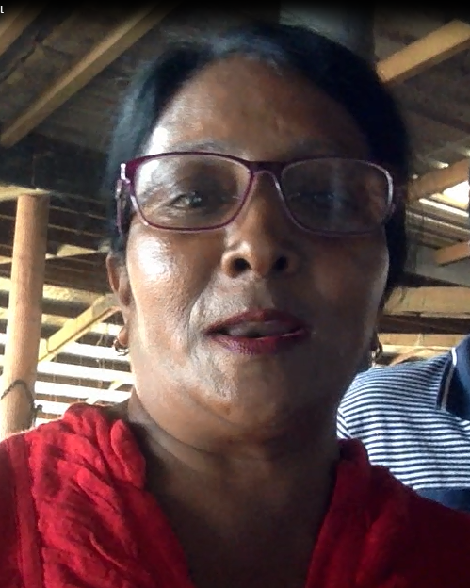
Pushpa Wati Sainimili Haravanua

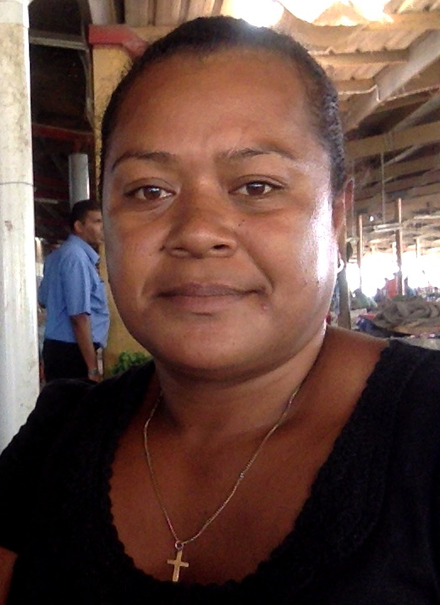
Savila Devi Lusiana Bulu
This experience was echoed by Tavua participants 2015 participants Kiran Lata, and Miliakere Tavaga. Kiran Lata also related how joining a club made up by a few other market vendors who had done the CMBE training, led to a shared savings scheme for special events like an end of year picnic, and a Christmas party. Kiran said that before the savings club she had not ever attended a social event without family members being the focus of the event.
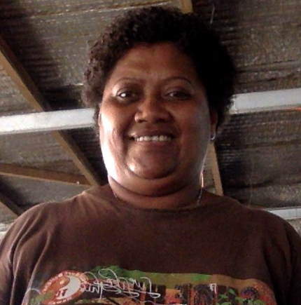
Kiran Lata Miliakere Tavaga
In Labasa, in the initial roll-out of the CMBE training in May 2016, where whole-day training was introduced and both Rounds 1 and 2 were completed, certificates of participation for both rounds were presented to all participants at the end of the training session.
Participants at a training session held for market vendors from the Namuka Tikina in Macuata who vend at the Labasa Market not only completed the training but also opened bank accounts with Westpac on the same day. Of the 23 participants (all female), 21 of them opened new bank accounts, and 2 re-activated Westpac accounts that they already had.
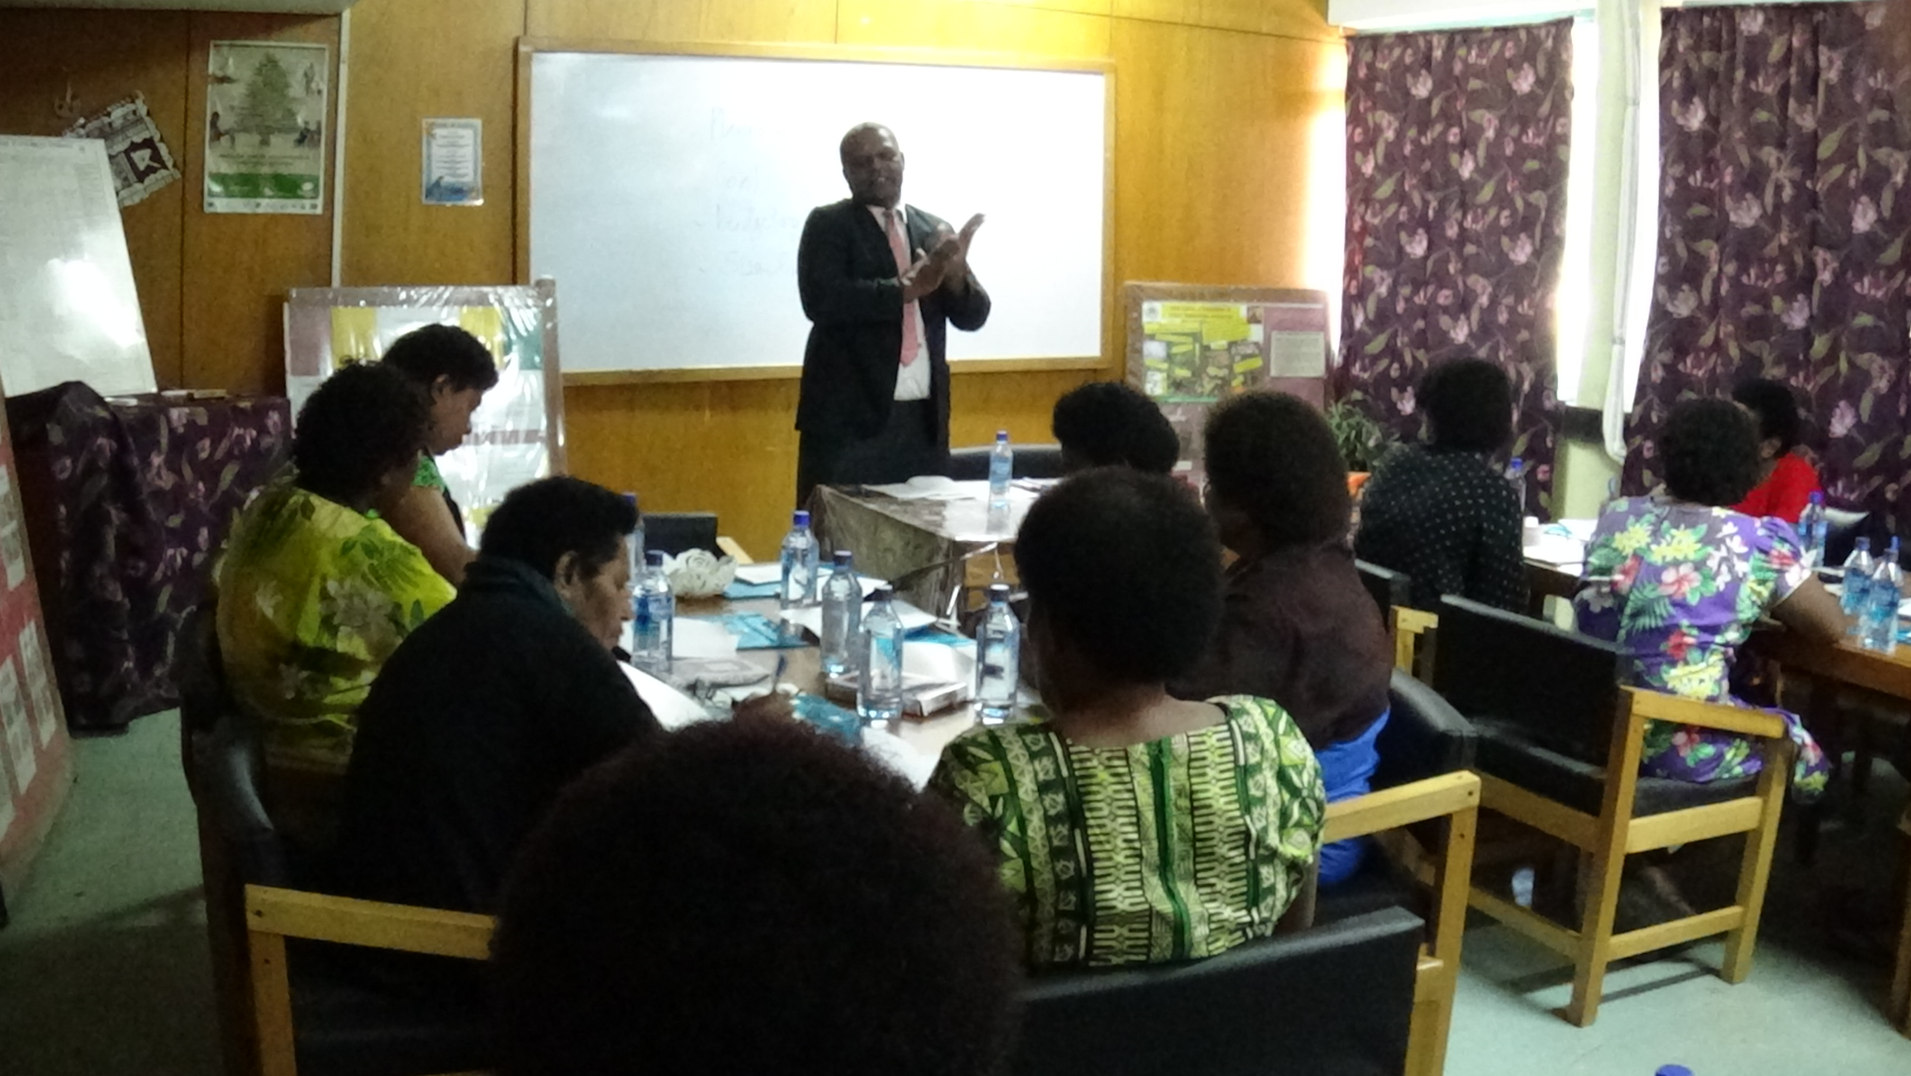
Mataiasi Daveta, Westpac Branch Manager Labasa at the time of the training, takes participants through the training.

Benefits of the IPI-VF Training - Testimonials
In Tavua, on a subsequent visit in July to conduct IPI-VF T2 training to earlier participants of T1, there was an opportunity to discuss with participants the benefits of the training conducted earlier and capture evidence of indicators being monitored. Mereoni Qenicolo, Nisha Bi, and Sulochna Devi are all farmer vendors who not only attended the CMBE training in 2015 but also attended the IPI-VF training in 2016. They were enthusiastic not only about the skills they learnt in the CMBE training but also in the IPI-VF training. All participants interviewed confirmed the value of the record keeping aspect of the training, especially the different aspects of the farming business to be recorded, as taught in the IPI-VF training. The pictures below show the participants with sample pages of their business records.
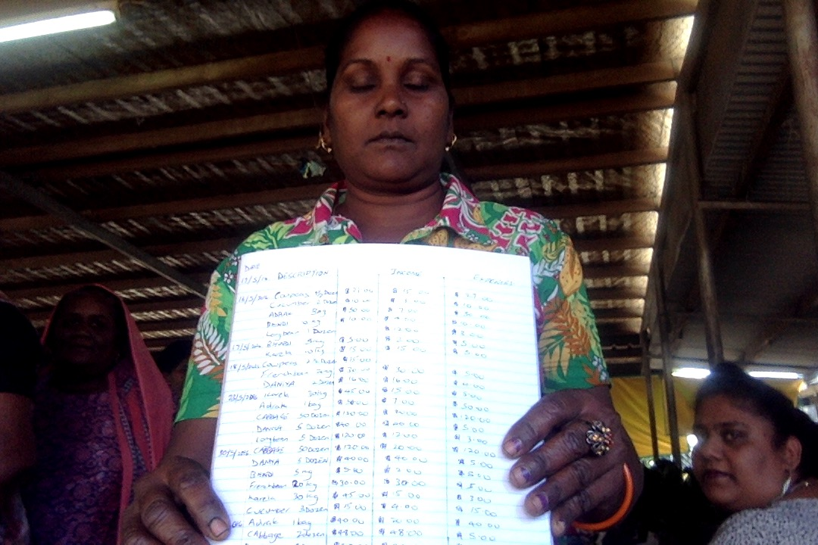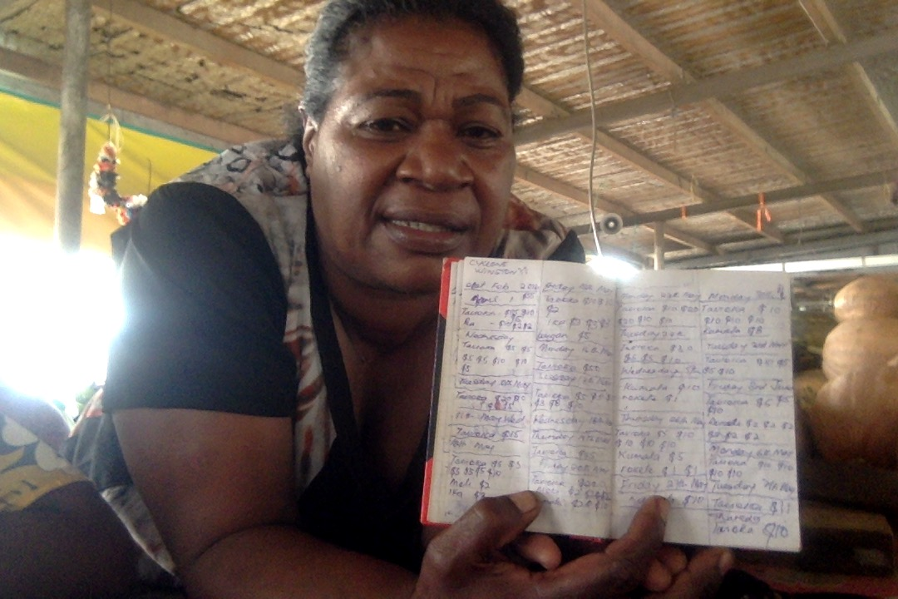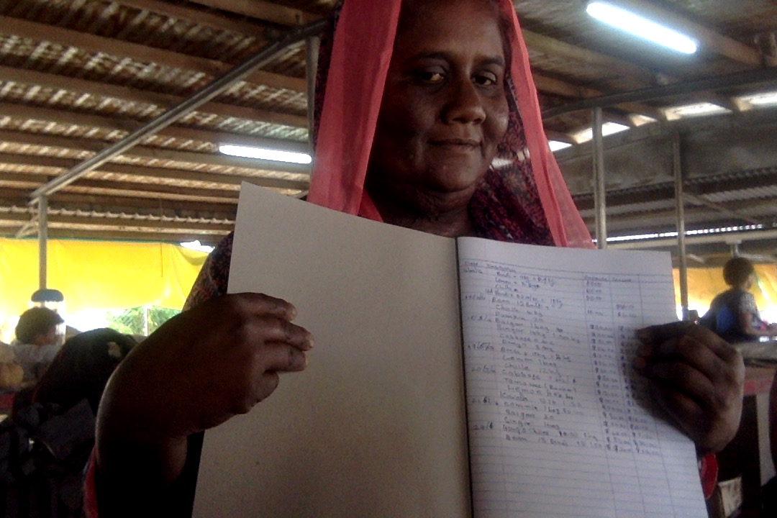
Sulochna Devi Mereoni Qenicolo Nisha Bi

Other recipients of the IPI-VF T2 training in Ba who had not done CMBE gave similar endorsements of the value of the record keeping aspect of the training as taught in the IPI-VF training. The pictures below show Titilia Qiatabua, Prem Chand and Rina Devi with sample pages of their business records.

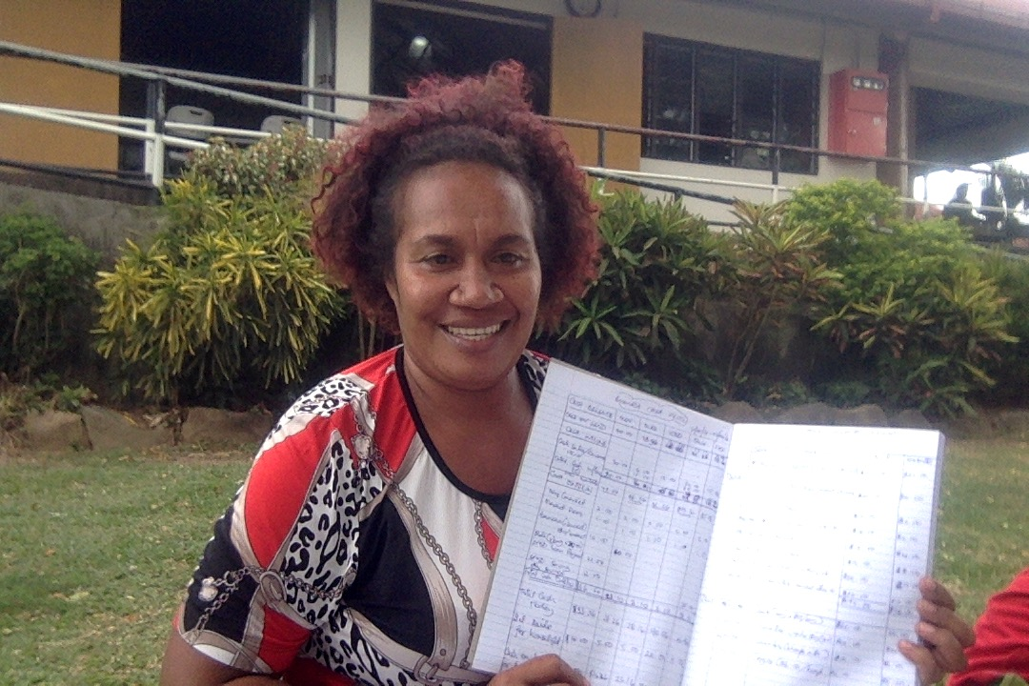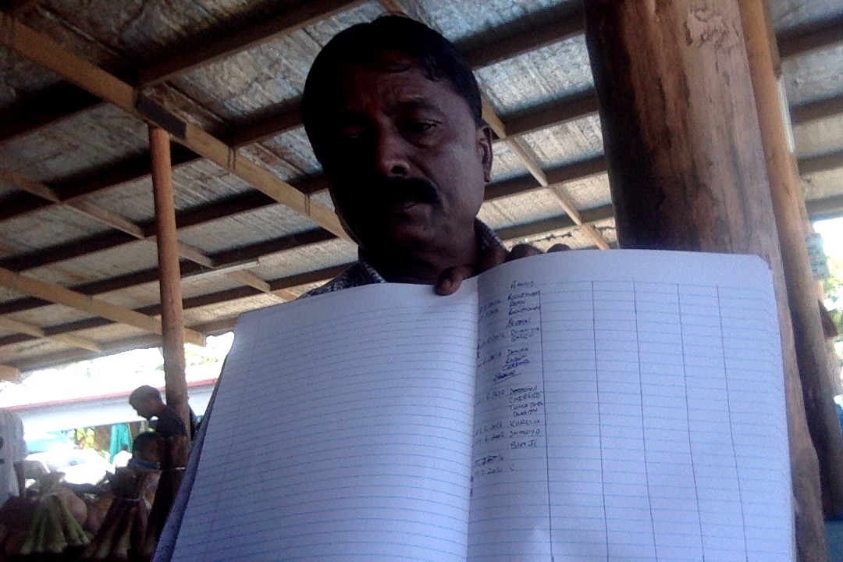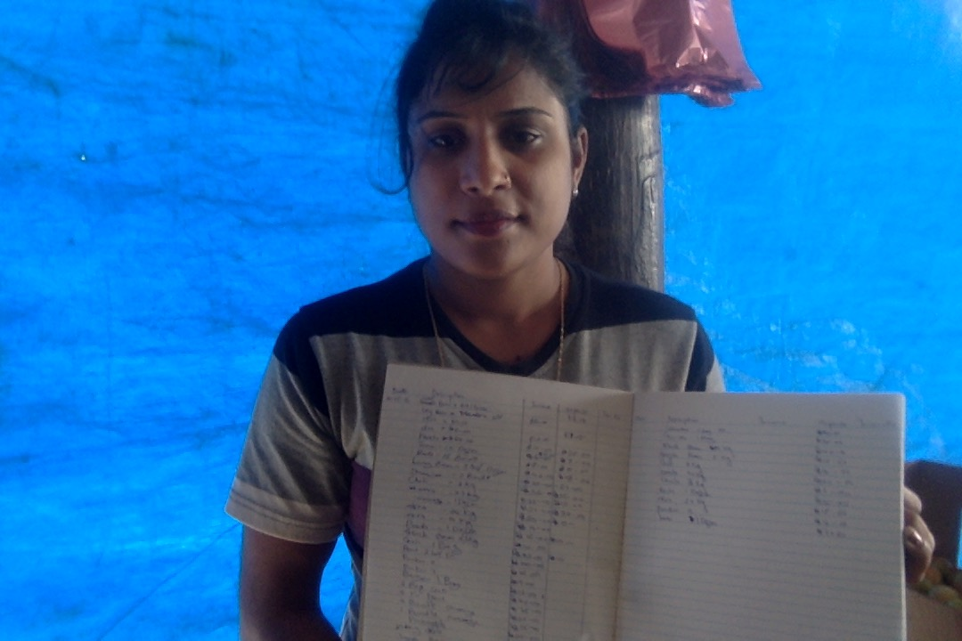
Titilia Qiatabua Prem Chand Rina Devi
All IPI-VF participants interviewed were greatly appreciative of the technical content of the agricultural training and said they had never been exposed to the information before. For many participants the information they learnt explained why they had struggled with some of their crops in the past, and the effectiveness of their use of fertilizers3.

